Project: emergency Crisis Responder

**Group Members:**

**Rohail Ahmed(Sp21-Bcs-077)**

**Muhammad Ali haider(Sp21-Bcs-057)**

**Submitted to: Sir Innayat ur Rehman**

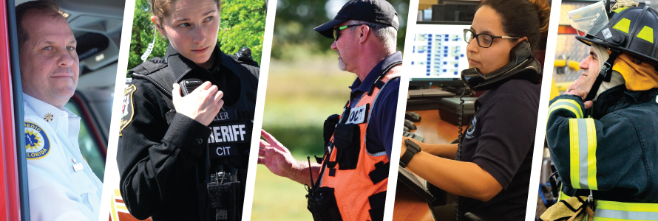

Crisis Responder

**Introduction:**

Is basically a kind of emergency service provider which operates in small city.

A small centre which is basically operating all the calls.

A user has basically four options:

**Police station**

**Fire brigade**

**Hospital**

**Anti-terrorist**

Based upon the problem the control centre provides the service using the dijkastra through the smallest path

**Data Structures used:**

**Trees-->** Store’s all data of call users.

**Queue-->** Add all calls in queue for admin to resolve.

**Graphs-->** Finding shortest distance from Calling user to service provider.

**Modules:**

**Police Station**:

There are 2 police stations located in city. A police has a number of (12).

Depending upon the seriousness of crime if there is local crime (i.e. mobile

snatching) then bike squad is send on the specific place by using the shortest

path with the help of **dijkastra** and is those are decremented from the total bike

squad present.

If there is big crime (i.e. bank robbery, Terrorism) then auto mobile of police is send.

Anti-Terrorist squad is also an option after that.

**Ambulance:**

There are 4 hospitals located in city:

A call number for the Ambulance is (1122) .

A user calls and if there is normal accident then the help

is provided to them with the help of bike squad**.**

On contrary if patient condition is serious and needed to shift in hospital the

ambulance service is provided

With the help of dijkastra by finding the smallest path

**Anti-Terrorist squad(SSG):**

There is one zarrar unit in city. These are specialized commandos act as a last resort.

If there is terrorist activity which police can’t handle,

then these squad is called . They are 20 in total.

**Fire Brigade:**

Similarly, if there is fire blown in some area

then Help is provided to particular area using the smallest

distance.